CORROSION AND CORROSION CONTROL

INTRODUCTION

Corrosion can be defined as the loss of materials as a result of chemical or electrochemical reaction with the environment. The annual cost of corrosion in India is around Rs. 600 crores. The loss due to corrosion include the cost of repair or replacement of the corroded component or equipments. By making proper use of existing corroded materials and techniques for corrosion prevention, about 25% of the estimated amount (Rs. 150 crores in India) can be saved.

Now a days it is necessary to pay more attention to corrosion because of increasing use of metals in all fields of technology and increase in air and water pollution there by resulting in a more corrosive environment.

Definition :
Metals combines with oxygen gives metal oxide is called corrosion.
Destruction of metals (or) deterioration of metals by the attack of environment is called corrosion.

Causes of corrosion
Metals occur in nature are in the following two forms :
1. Native state
The metals occur in native (or) free (or) uncombined state are non-reactive with the environment. They are noble metals exist as such in the earth crust they have very good corrosion resistance.
Example : Au, Pt, Ag, etc.,

2. Combined State
Except noble metals, all other metals are reactive and react with environment and form stable compounds, as their oxides, sulphides, chlorides, and carbonates. They exist in their form of stable compounds called ores and minerals.

Example : Fe2O3, ZnO, PbS, CaCO3, etc.,

The metal ores are converted into pure metal by the use of metallurgical process. The pure metal at higher energy will always have a tendency to go into the lower energy state by the attack of environment is called corrosion.

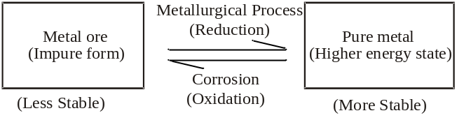

CLASSIFICATION OF CORROSION

The corrosion process is classified on the basis of mechanisms.
(i) Dry corrosion (or) Chemical corrosion
(ii) Wet corrosion (or) Electro chemical corrosion

Dry Corrosion (or) Chemical Corrosion
This type of corrosion occurs through direct chemical action of dry gases (or) corrodents such as oxygen, halogen, H2S, SO2, etc.,
This can be classified as follows,

a) Corrosion by oxygen (Oxidation corrosion)
Oxygen present in the atmosphere attacks metal surface resulting in the formation of metal oxide which is known as corrosion product and this process is known as oxidation corrosion.

Mechanism
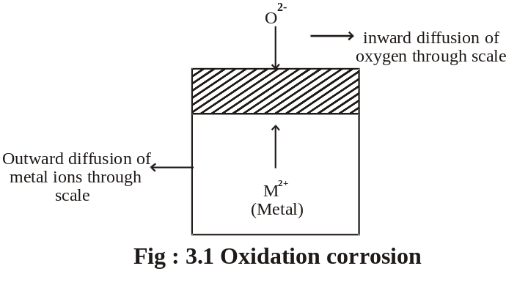

Oxidation first occurs at the surface of the metal resulting in the formation of metal ions (M2+)

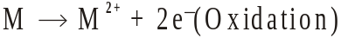

Oxygen is converted to oxygen ion (O2-)

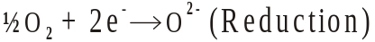

Metal ions combines with oxygen ions forms the metal oxide film

Nature of the metal oxide films formed

There are generally four types of metal oxide films are formed.

(i) Stable film
If the oxide film is stable, there is no further penetration of oxygen ions to the metal part. There is no further corrosion takes place. Thus the stable film act as protective coating.
Examples : Al, Sn, Pb, Cu, etc.,

(ii) Unstable film
In the case of noble metals the metal oxides formed decomposes reversibly to the metal and oxygen.

In this case, the corrosion is a continuous process.
Examples :
Pt, Ag, Au, etc.,

(iii) Porous film
The oxide layer formed in some cases are porous. In this case atmospheric oxygen can easily move to the metal surface.
So corrosion is a continuous process.
Examples :
Li, Na, K, etc.,

(iv) Volatile film
The oxide layer formed in some cases are volatile. So the oxide film volatises as soon as they are formed. The fresh metal surface is kept exposed all the time for further attack. Thus it act as a non-protective coating.

Example :
Molybdenum oxide film.

b) Corrosion by other gases
Other gases present in the atmosphere like SO2, CO2, Cl2, H2S etc,. can also attack the metals.
For example,
1. Chlorine attacks on silver forms protective layer of silver chloride, it prevents further corrosion.

2.But Sn reacts with chlorine present in the atmosphere forms SnCl₂.It is volatile. So the corrosion is a continuous process.

3.Metals combines with H2S gas to liberate atomic hydrogen.

The atomic hydrogen is very reactive and penetrate the metal and occupies the voids of the metal.

The atomic hydrogen recombines inside the metal and develop pressure which leads to cracking of the metal. This is known as “Hydrogen Embrittlement”.

4.Atomic hydrogen are formed by dissociation of H2 gas at high temperature.
5. The atomic hydrogen is highly reactive and combine with carbon present in the metal forms CH4 gas which leads to cracking of the metal surface. This is known as “Decarburisation”.

c) Liquid metal corrosion
This type of corrosion is due to the chemical action of flowing liquid metals at high temperature on solid metal.
Such type of corrosion are found in nuclear power plants.

Wet Corrosion (or) Electrochemical Corrosion

This type of corrosion occurs when,
(i) The conducting electrolytic liquid is in contact with metal.
(ii) Two dissimilar metals are partially dipped in the electrolyte.

In the above condition one part of the metal becomes anode and the remaining part becomes cathode.

In anodic area
Oxidation takes place with the liberation of electrons.
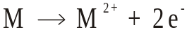

In cathodic area
Depending upon the nature of electrolytic solution, two types of reaction takes place at cathode.

(i) Hydrogen evolution mechanism
(ii) Oxygen Absorption mechanism

This can be explained as follows,

(i) Hydrogen evolution mechanism
When the conduction medium is highly acidic or completely free from dissolved oxygen, hydrogen evolution takes place. For example, corrosion of iron metal by industrial waste containing H+ ion undergoes this type of corrosion.

In this type of corrosion, anodes possess large surface area and less cathode area.

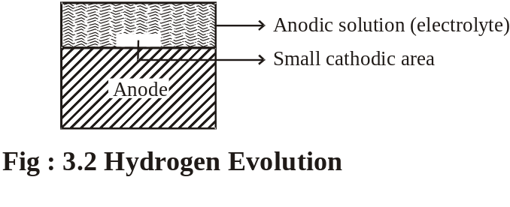

At anode : 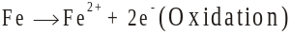
At cathode : 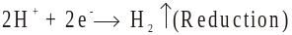
Overall : 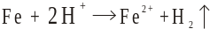

(ii) Oxygen Absorption mechanism
This type of mechanism takes place when base metals are in contact with neutral solution like H2O with dissolved oxygen. An example of this kind of corrosion is the rusting of paint coated iron. If there is any crack in the paint coated iron, that area acts as anode.
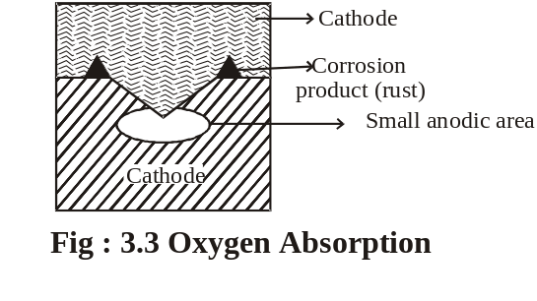
The liberated electrons flows from the anode to the cathode through the metal and accepted along the electrolyte and oxygen at cathode.

At anode : 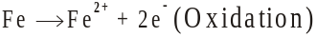
At cathode :
Overall :

If enough oxygen is present, ferrous hydroxide is converted into ferric hydroxide.

Differences Between Chemical and Electro Chemical Corrosion
Sl.  No | Dry (or)  Chemical Corrosion | Wet(or)Electro Chemical Corrosion
1. | It occurs in dry state | It occurs in presence of moisture (or) electrolyte
2. | It follows adsorption mechanism | It follows the mechanism of electro chemical reaction.
3. | Corrosion product accumulate on the same spot, where corrosion occurs. | Corrosion occurs at anode while products gather at cathode
4. | Uniform corrosion behaviour is seen, i.e., either the whole surface of the metal in contact with the medium corrodes, or it does not. | Localised corrosion occurs. i.e., one metal surface alone is corroding even though both metal surfaces are in contact with the medium.
5. | Only heat evolution can be observed. | Due to electron flow from the site of oxidation to site of reduction, current flow can be observed.
Galvanic Corrosion
This type of electrochemical corrosion takes place when two dissimilar metals are joined in the presence of electrolyte. The metal with higher negative electrode potential acts as anode and the remaining parts acts as cathode.

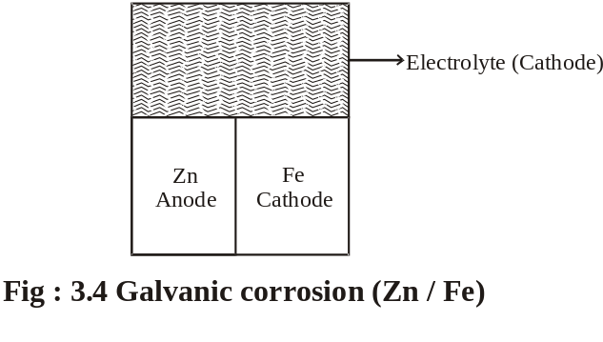
At anode : 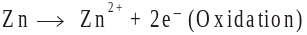
At cathode :
Overall :

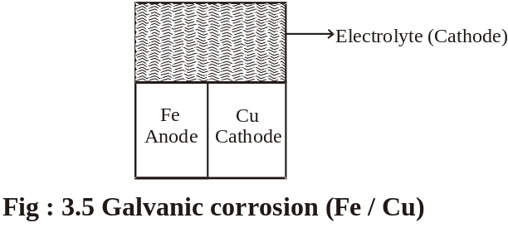
At anode : 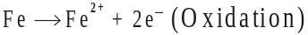
At cathode : 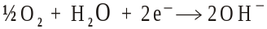
Overall :
The galvanic corrosion can be avoided by

1. Coupling of metals very close in the emf series.
2. Providing an insulating material between the two metals.
3.The area of the cathode is always smaller than anodic area.

Concentration Cell Corrosion (or) Differential Aeration Corrosion
This is the most common type of electrochemical corrosion that takes place when the metal is partially dipped in solutions, metals partially covered with dust, sand, water drops etc. The less aerated part act as anode and the more aerated part act as cathode. The anodic part undergo corrosion and the cathodic part is prevented. This type of corrosion called as Concentration Cell Corrosion.

Example : 1
When a metal is partially immersed in a solution it has very poor aeration when compared with the metal that is outside the solution.
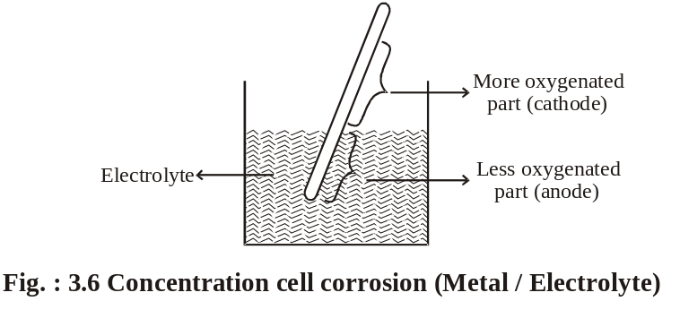
The less aerated part act as anode and the more aerated part act as cathode.
Example: 2
The another example of this type of corrosion is the metal parts partially covered with dust, sand, water drops etc. This type of corrosion is called as pitting corrosion.
Pitting Corrosion
Pitting is a localized attack, resulting in the formation of a hole around which the metal is relatively unattached.

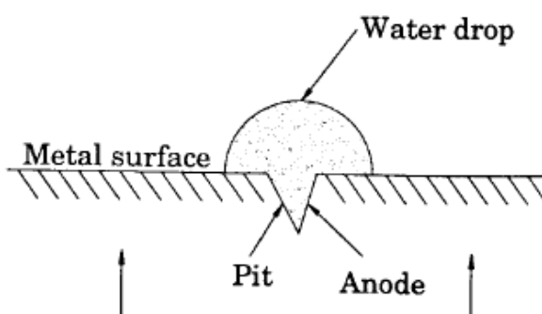
Cathode

Fig Pitting Corrosion

The area covered by the drop of water act as an anode due to less oxygen concentration and suffers corrosion. The uncovered area (freely exposed to air) act as a cathode due to high oxygen concentration.
The rate of corrosion will be more, when the area of cathode is larger and the area of anode is smaller.

At anode : 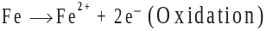
At cathode :
Overall
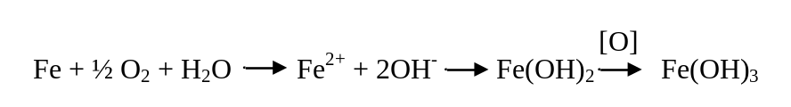
This type of intense corrosion is called pitting.

Example: 3
Differential aeration corrosion may also occur in different parts of pipeline. The buried pipelines (or) cables passing from one type of soil to another, say, from clay (less aerated) to sand (more aerated) may get corroded due to differential aeration.

Example: 4
This type of corrosion is also takes place in wire fence. In this case the areas where the wires cross are less aerated than the other parts of the fence. The corrosion takes place at the wire crossings because less aerated part act as anode.

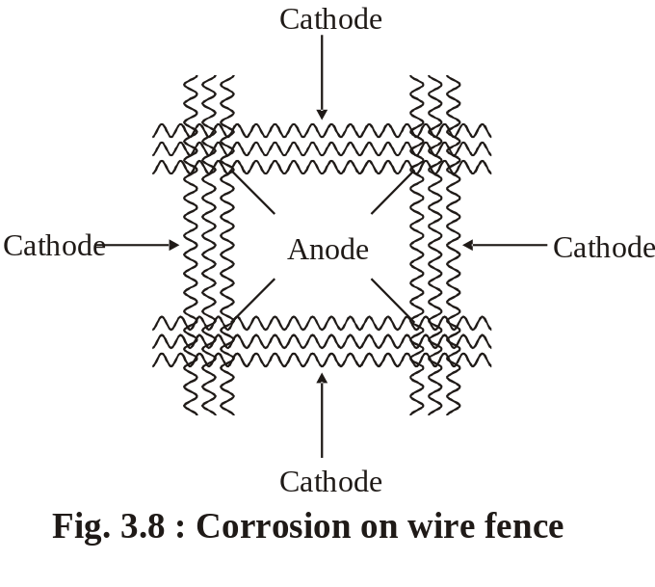

Water line corrosion
Water line corrosion is also called as differential aeration corrosion leading to the formation of oxygen concentration cell. It occurs due to the storage of water in a metal container.

Example:
Water stored in a steel tank (Fig )

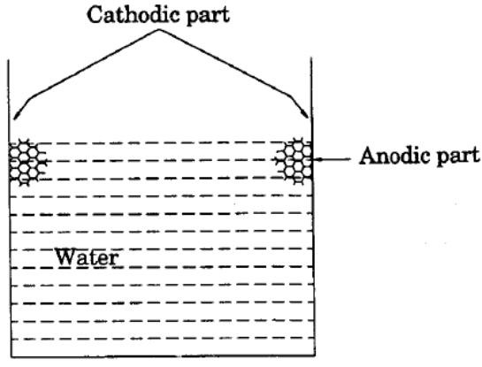
Fig water line corrosion

When water is stored in a steel tank, corrosion occurs along the line just beneath the water meniscus. The highly oxygenated area ( above the water line) acts as the cathode and is unaffected by corrosion, while the poorly oxygenated area ( beneath the water line) acts as anode and highly affected by corrosion.
Corrosion reactions
At Anode : Fe → Fe²⁺ + 2e⁻
At Cathode : 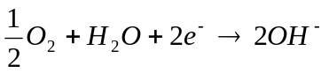
(O)
Net reaction : Fe²⁺ + 2OH⁻ → Fe(OH)₂ Fe(OH)₃

Draw back: Water line corrosion is a serious problem for ocean going ships.
Prevention: using special “ antifouling paints”.

FACTORS INFLUENCING RATE OF CORROSION

Corrosion is a kind of reaction that takes place in the metal by the influence of its environment. Hence both (i) the nature of the metal & (ii) the nature of environment play equal part in the corrosion of the metal. The following are the factors responsible for the corrosion.

I. Nature of the Metal
(a) Position of metal in the EMF series
Metals higher (-) in the galvanic series undergo strong corrosion and lower (+) in the EMF series undergo less corrosion.

(b) Relative areas of anode and cathode
Corrosion will be severe if the anodic area is small and the cathodic area is large. Larger cathodic area of the cathode will create demand of more electrons, which can be met by the smaller area of the anode only by undergoing more corrosion.

(c) Over potential
Corrosion is very slow if hydrogen over voltage of the cathodic metal is high. The over potential of a metal in a corrosive environment is inversely proportional to corrosion rate.

(d) Nature of the surface film
Stable oxide film restricts further corrosion. Unstable, volatile and porous oxide films enhances further corrosion.

(e) Purity of the metal
Impurity present in pure metal creates heterogenity and leads to galvanic corrosion. If the percentage of purity increases the corrosion rate decreases.

(f) Stress
Metals part under stress can become anode and undergo corrosion. This type of corrosion is called stress corrosion.

II. Nature of the Environment

(a) Temperature
Increase of temperature increases diffusion of ions in the corrosive medium and thus rises the corrosion rate.

(b) Humidity
Concentration of water vapour present in the atmosphere is known as humidity. If the humidity increases the corrosion rate increases, at a particular point a sudden increase in the corrosion rate is observed, that is called critical humidity.
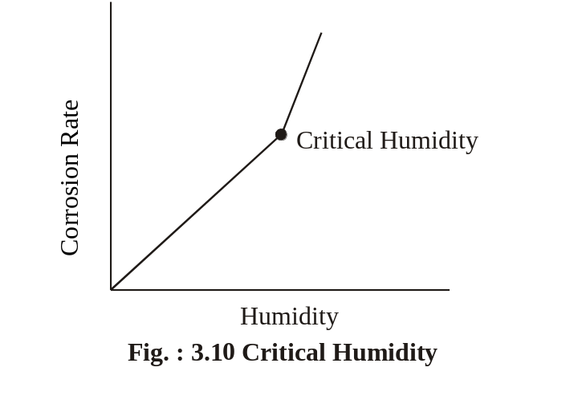
(c) Presence of Corrosive gases
Corrosive gases like So2, H2S, fumes of HNO3, H2SO4, acetic acid etc, enhances the corrosion rate.
(d) Presence of suspended solids
Suspended particles like chemically active, chemically inactive
and chemically neutral dust particles enhances the corrosion rate.
(e) pH
The corrosion rate is maximum when the environment is more acidic (pH=5) and minimum when the environment is more alkaline (pH=11). In general, acidic medium is more corrosive than alkaline or neutral medium.

CORROSION CONTROL METHODS

The corrosion is controlled by the following methods.
(i) Sacrificial anodic protection
(ii) Impressed current cathodic protection
iii) Control of corrosion by modifying the metal
(iv) Corrosion Inhibitors.

Sacrificial Anodic Protection Method
In this method, the metallic structure to be protected is made cathode by connecting it with more active metal (anode metal). So that all the corrosion will concentrate only on the active metal. The artificially made anode thus gradually corroded protecting the original metallic structure. Hence, this process is otherwise known as sacrifical anodic protection.

Aluminium, Zinc, Magnesium are used as sacrificial anodes.

This method is used for the protection of ships and boats. Sheets of Mg or Zn are hung around the hull of the ship. (Fig. 3.11).

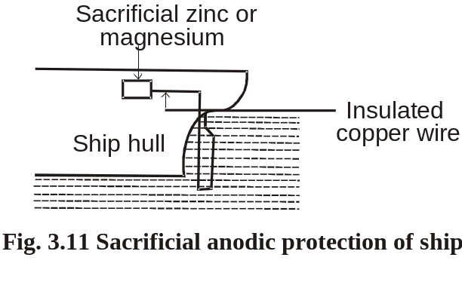
Zn or Mg will act as anode compared to iron (ship or boat is made of iron), so corrosion concentrates on Zn or Mg. Since they are sacrificed in the process of saving iron, they are called sacrificial anodes.
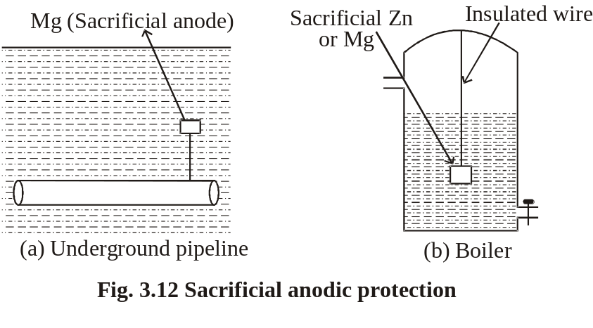

Important applications of sacrificial anodic protection are

a. Protection of underground pipelines, cables from soil corrosion (Fig. 3.12(a)).
b. Insertion of Mg sheets into the domestic water boilers to
prevent the formation of rust (Fig. 3.12(b)).
c. Calcium metal is employed to minimize engine corrosion.

Impressed Current Cathodic Protection Method
In this method, an impressed current is applied in the opposite direction of the corrosion current to nullify it, and the corroding metal is converted from anode to cathode.
This can be done by connecting negative terminal of the battery to the metallic structure to be protected, and positive terminal of the battery is connected to an inert anode. Inert anodes used for this purpose are graphite, platinised titanium. The anode is burried in a “back fill” (containing mixture of gypsum, coke, breeze, sodium sulphate). The “back fill” provides good electrical contact to anode (Fig. 3. 13).
Important applications of impressed current cathodic protection are structures like tanks, pipelines, transmission line towers, marine piers and laid-up strips, etc.

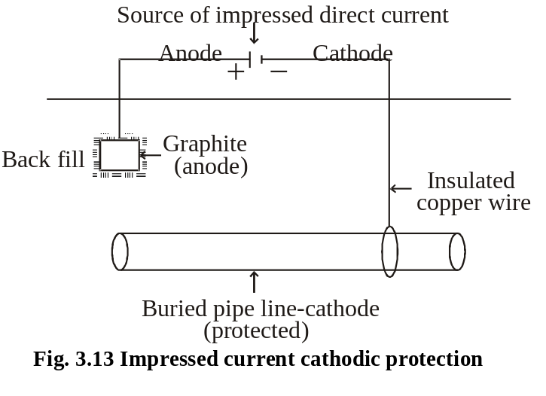

This type of protection is given to underground water pipe lines, oil pipe lines, ships, etc.

Comparison of Galvanic method (Sacrificial anode) and Impressed current cathodic method

Sl.No | Sacrificial anode method | Impressed current method
1. | No external power supply is necessary. | External power supply must be present.
2. | This method requires periodical replacement of sacrificial anode. | Here anodes are stable and do not disintegrate.
3. | Investment is low. | Investment is more.
4. | Soil and microbiological corrosion effects are not taken into account. | Soil and microbiological corrosion, corrosion effects are taken into account.
5. | This is most economical method especially when short-term protection is required. | This method is well suited for large structure and long term operations.
6. | This method is suitable when the current requirement and the resistivity of the electrolytes are relatively low. | But this method can be practiced even if the current requirement and the resistivity of the electrolyte are high.

Corrosion Inhibitors
A corrosion inhibitor is a substance which reduces the corrosion of a metal, when it is added to the corrosive environment.

Types of Inhibitors
1. Anodic Inhibitors
Examples : Chromates, nitrates, phosphates, tungstates (or) other ions of transition elements with a high oxygen content.
Anodic inhibitors are those that prevent the corrosion reaction, occurring at the anode, by forming an insoluble compound with the newly produced metal ions. These precipitates are adsorbed on the metal (anode) surface, forming a protective film and reducing the corrosion rate.
Though this type of control is effective, it may be dangerous, since sever local attack can occur, if some areas are uncovered.

2. Cathodic Inhibitors
In an electrochemical corrosion, the cathodic reactions are of two types depending upon environment.

(a) In An Acidic Solution
Examples : Organic inhibitors heterocyclic nitrogen compounds, heavy metal soaps.
In an acidic solution, the cathodic reaction is evolution of hydrogen i.e., like amines, mercaptans, thioureas, substituted ureas, etc.,
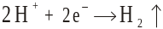

The corrosion can be reduced in two ways
(i) By slowing down the diffusion of H+ ions to the cathode. This can be done by adding organic inhibitors like amines, pyridines, etc., which are adsorbed at the metal surfaces.
(ii) By Increasing the over voltage of Hydrogen evolution. This can be done by adding antimony and arsenic oxides which deposit adherent film of metallic arsenic and antimony at the cathodic areas.

(b) In a Neutral Solution
Examples :
Sodium sulphite (Na2SO3), hydrazine (N2H4).
In a neutral solution, the cathodic reaction is

The corrosion can be reduced in two ways.
(i) By eliminating the oxygen from the neutral solution, there by formation of OH- ions are inhibited. This can be done by adding reducing agents like Na2SO3, N2H4 etc.
(ii) By eliminating the OH- ions from the neutral solution. This can be done by adding Mg, Zn or Ni salts. These react with OH- ions form insoluble hydroxides, which are deposited on the cathode forming less impermeable self - barriers.

3. Vapour Phase Inhibitors (VPI)
Examples : Dicyclohexylammonium nitrate, benzotriazole, etc.
Vapour phase inhibitors (VPI) are organic inhibitors, which readily vapourise and form a protective layer on the metal surface. VPI are used in the protection of storage containers, packing materials, sophisticated equipments, etc.

iv) Control of corrosion by modifying the metal

1. By selection of the metal
Selection of right type of metal is the main factor for corrosion control. Thus, noble metals are used in ornaments and in surgical instruments.

2. By using pure metal
Pure metals have higher corrosion resistance. Even a small amount of impurity may lead to severe corrosion.

3. By alloying
Corrosion resistance of many metals can be improved by alloying. For example, stainless steel containing chromium produce a coherent oxide film, which protects the steel from further attack.

4. By proper design
Some of the important rules for designing, which must be observed, are given below.

i) Avoid galvanic corrosion
If two different metals are joined , galvanic corrosion will occur. In such a case galvanic corrosion is prevented by
a) Selecting the metals as close as possible in the electrochemical series.
b) Providing smaller area for cathode and larger area for anode.
c) Inserting an insulating material between the two metals. (Fig)

ii) Drainage affects corrosion
Tanks and other containers must be designed in such a way that, the whole of the liquid should be drained off completely. (Fig)

iii) Avoid sharp corners and bends
Sharp corners and bends should always be avoided, and hence erosion corrosion can be avoided by smooth corners or curved pipe bends.
iv) by avoiding crevices
Crevices allow moisture and dirt, which results in increased electrochemical corrosion. This can be prevented by filling the crevices with a filler.
Example: Riveted joints produce crevice corrosion, so welded joints are preferred.

Paints
Paints are stable mechanical mixtures of one (or) more pigments.
Paint is a dispersion of pigments in to the drying oil.
The vehicle or drying oil is a film forming material, to which other ingredients are added in varying amounts.

Requisites (or) Characteristics of a good Paint
It should spread easily on the metal surface.
It should have high covering power.
It should not crack on drying.
It should adhere well to the surface.
The colour of the paint should be stable.
It should be a corrosion and water resistant.
It should give a smooth and pleasing appearance.
It should dry quickly.

Protective Coatings

Introduction
Protective coatings are used to protect the metals from corrosion. Protective coatings act as a physical barrier between the coated metal surface and the environment. However they are also used for the decorative purpose. In addition to corrosion protection and decoration, they import some special properties such as hardness, electrical properties, oxidation-resistance and thermal insulating properties to the protected surface.

Coatings like paints, varnishes, lacquers and enamels are called organic coatings. They are applied on the metallic surfaces for both corrosion resistant and decoration.

Classification
